**Website Issues & Modifications**

1. **Footer Page**
   * The map logo is not aligned properly with the other icons (mail and phone number). It should be centered consistently.
   * 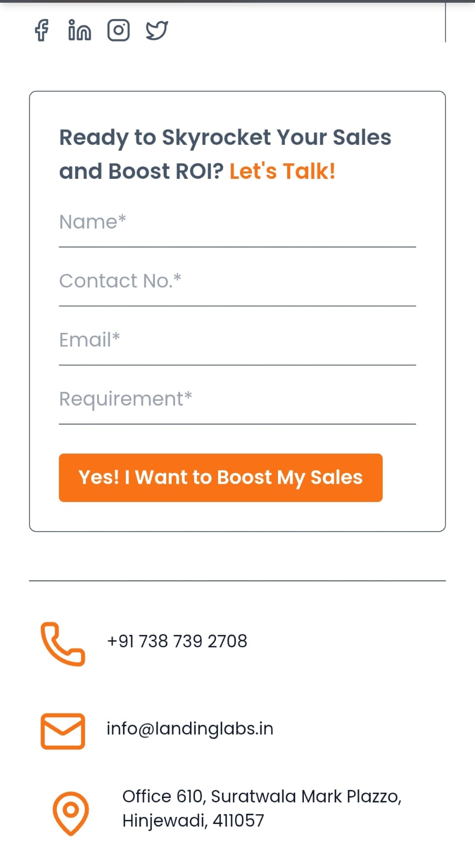
2. **Home Page**
   * In the cards (Engagement, Traffic, etc.), the arrow lines inside the circular icons (1, 2, 3) are missing. These should be added for proper visual flow.
   * 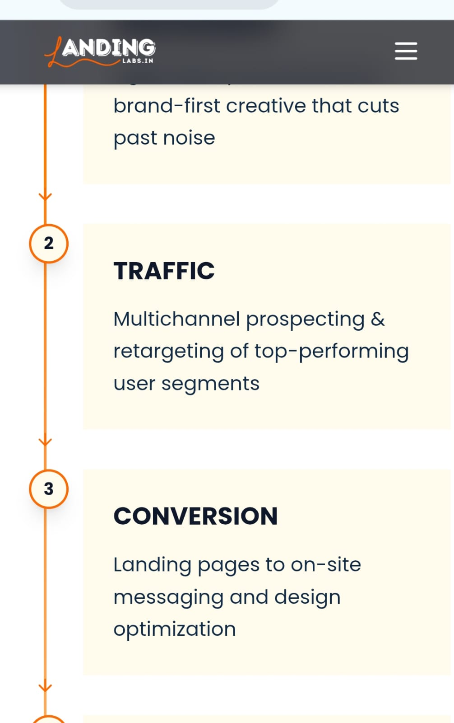
3. **Career Page**
   * The first image is not aligned properly; it overflows into the navigation bar section.
   * There is extra spacing between the "See Open Roles" and "Available Positions" sections.
   * The headings such as "Our Processing" and "Questions" have too much space above them. Spacing should be reduced for consistency.
   * 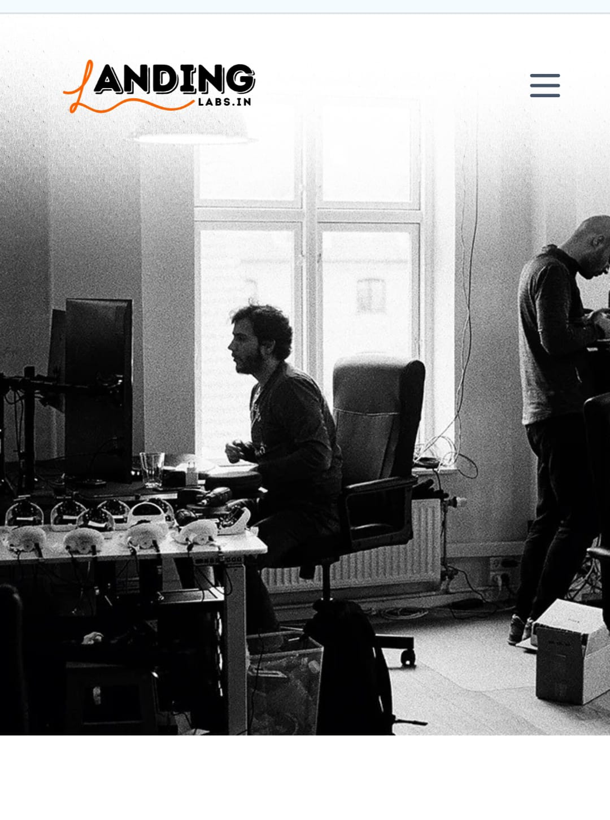
   * 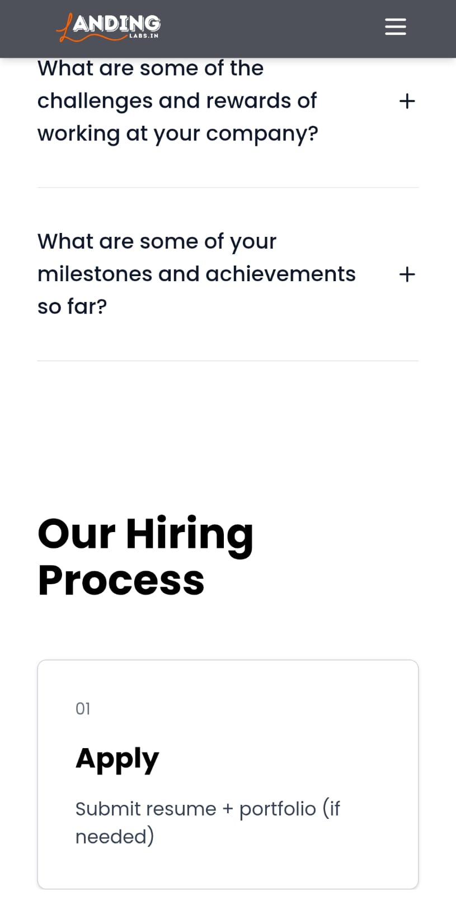
4. **About Page**
   * The "Get Started" and "Learn More" buttons have excessive width compared to standard buttons; they should be resized.
   * In the "Landing Labs" section, the image, logo, and paragraph have too much spacing between them. The gaps should be reduced for better alignment.
   * 
   * 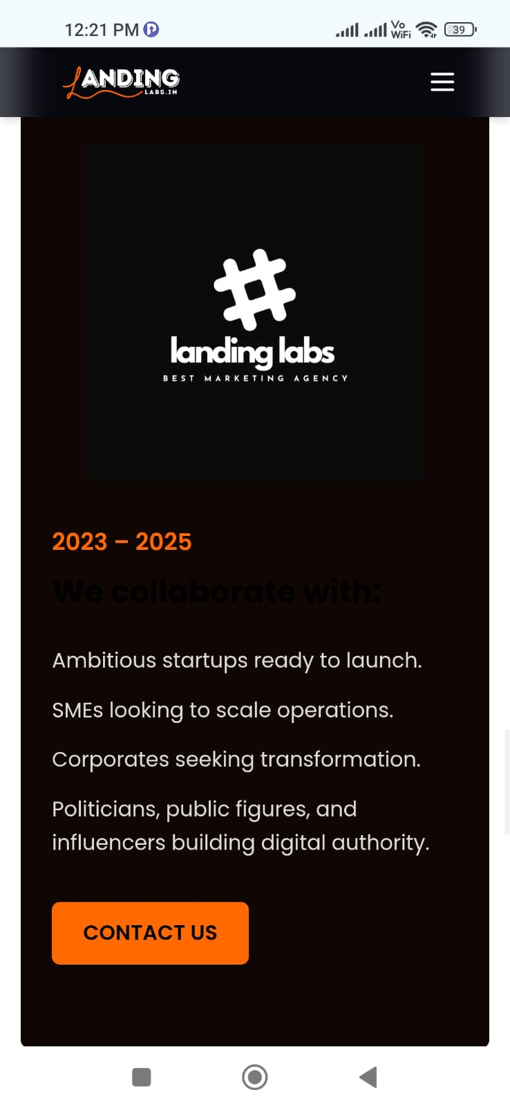

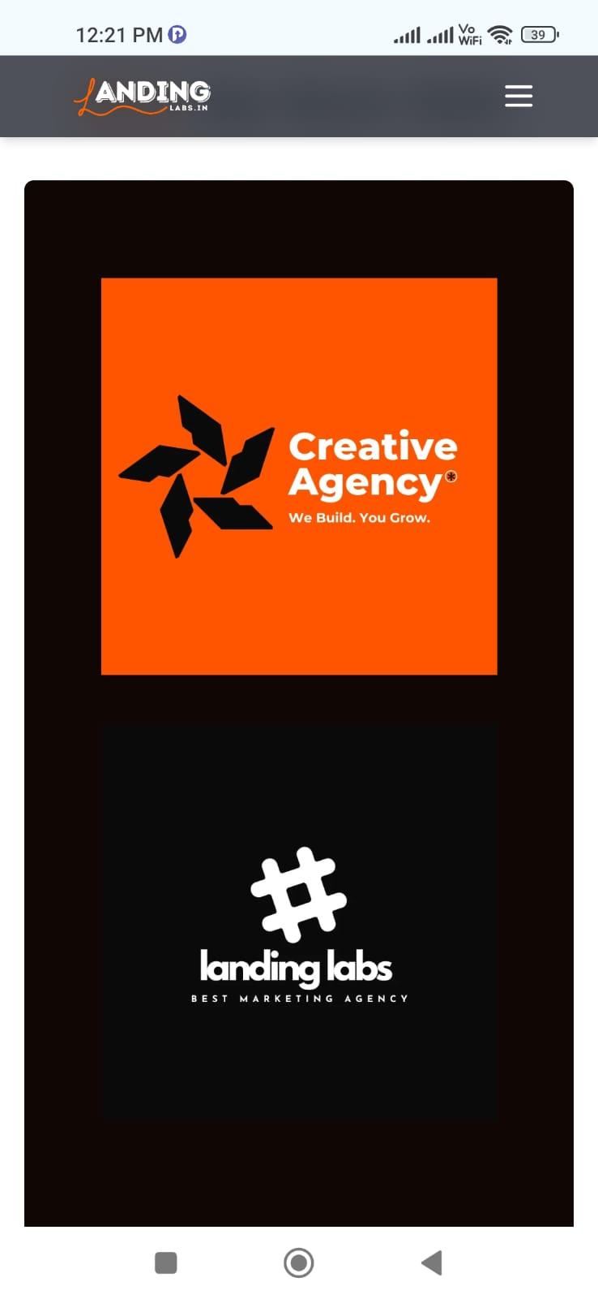

1. **Portfolio Page**
   * The navigation bar is not displayed with proper width and height, and it is not centered. It should be adjusted for better layout.
   * 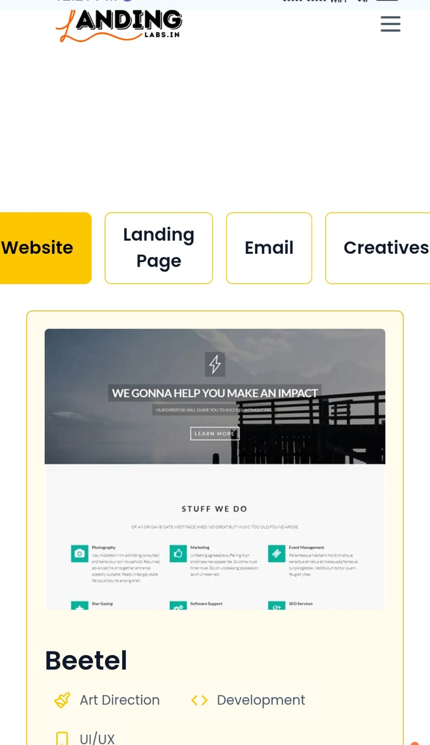
2. **Services Section**
   * The first image at the top is misaligned. It needs to be adjusted for proper positioning.
   * 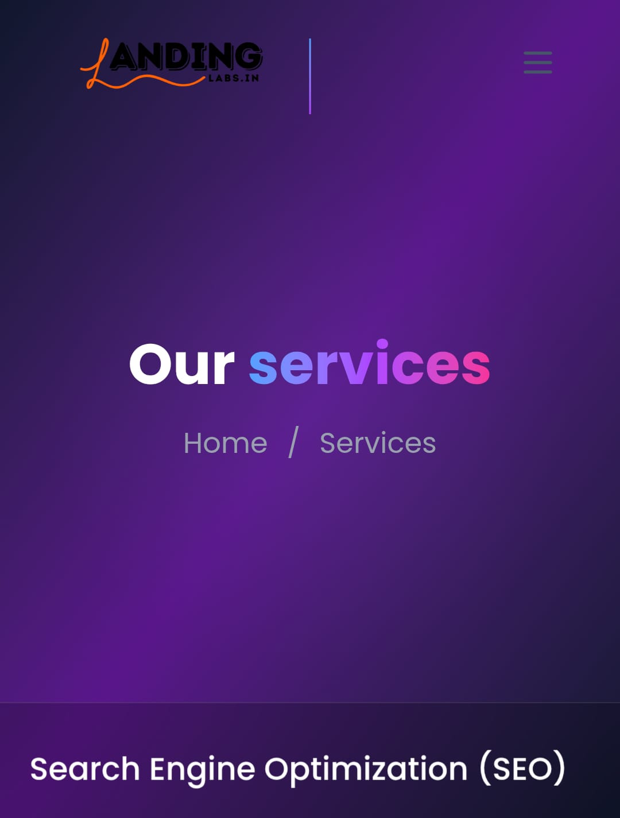

7. **Logo Visibility on Scroll**

* + Currently, the logo appears **black before scrolling**, which makes it almost invisible on a dark background.
  + After scrolling, it turns **white**, which looks good and is clearly visible.
  + The default (before scrolling) logo should also be made visible by adjusting the color/contrast.

**8. Logo Inside Cards**

* + When clicking on a card and entering into the card detail view, the **logo is not visible**.
  + It appears as **black text**, which blends into the background and cannot be seen properly.
  + The logo color should be adjusted to ensure visibility in both normal and dark sections. 